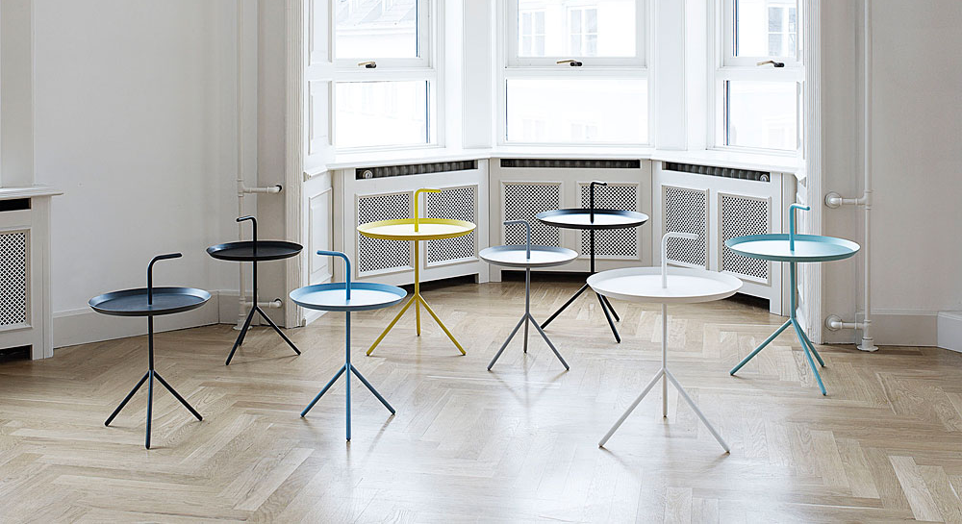

DLM (Don’t Leave Me)

Description
With its handle on top, the idea behind the side table DLM is obvious – bring me along! A tray with legs and a handle, enabling you to bring your coffee cup as well as the table along when moving around the house - to your favourite chair or to the terrace - a table suitable everywhere. The table is an alternative to traditional coffee tables, which are often big, heavy and immobile. This is a fun table for modern life.

Finish
Steel tube, pressed steel sheet, powdercoated

Colours
Black
Light blue
Aqua green
Cream
White
Light Grey
Dark Grey
Yellow

Dimensions
Height / Width / Depth
580mm / 380mm / 380mm
650mm / 480mm / 480mm

